**Universal Design Principles & Perception Laws**

**Usability Principles (Bruce Tognazzini)**

* Fashion should never trump usability (**Aesthetics**).
* Bring to the user all the information and tools needed for each step of the process (**Anticipation**).
* Computer interface, and task environment all “belong” to the user (**Autonomy**):
  + Customized interfaces,
  + Keep user informed: status, errors, progress indicators, …
* When using color to convey information in the interface, also use clear, secondary cues (**Color**).
* Consistency: levels of consistency, induced inconsistency, continuity, with user expectations.
* Default Values: easy to blow away, not everything default.
* Discoverability: Any attempt to hide complexity will serve to increase it, if user cannot find it, it does not exist:
  + Controls should be visible, communicate the gestural vocabulary, use active discovery, …
* Look at the user’s productivity, not the computer’s (**Efficiency**):
  + formularies, error messages, latency reduction.
* Explorable interfaces: Actions reversible:
  + always allow undo, back to home page, visible navigation.
* Good Metaphors.
* Protect Users’ work: Ensure that users never lose their work**.**

**Universal Principles of design**

Aesthetic-Usability Effect.

* Aesthetics play an important role in the way designs are used.
* Aesthetic designs look easier to use, and encourage its use more than non-aesthetic designs.
* This effect produces the perception that an aesthetic design is easier to use than a non-aesthetic design.

We must devote important efforts to improve our designs.

Fix a visual hierarchy.

* Modular scale guarantees harmonious proportions.
* How to make a modular scale:
  + Choose a ratio (for example, the golden ratio, 1:1.618).
  + 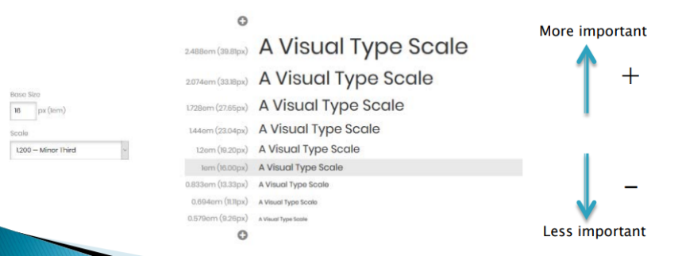Choose a base size (i.e., 10), then multiply and divide to get many resonant numbers:

Correct alignment.

* Elements must be aligned, this creates a sense of unity and cohesion, as well as facilitates reading.

Define a grid.

There are infinite options:

* Modular grid. One element can occupy several neighboring cells.

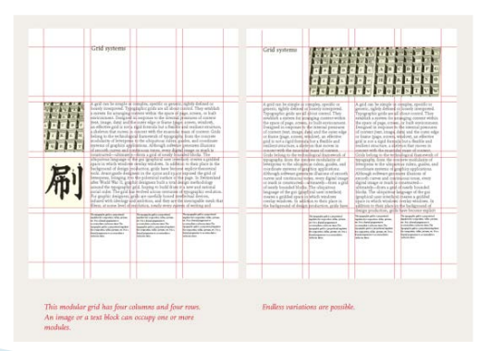

* Base line grids ensure the vertical rhythm between columns.
  + The font sizes, line heights and margins are fixed to fit in a base grid of fixed height.
  + Try gridlover for grid generation!

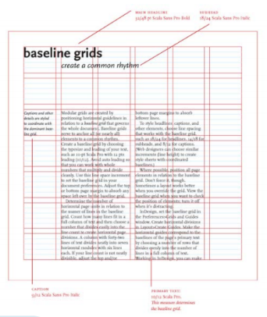

Nesting.

Nesting is also a visual queue of the hierarchy of the information shown. We need to be careful when designing the visual nesting dependences.

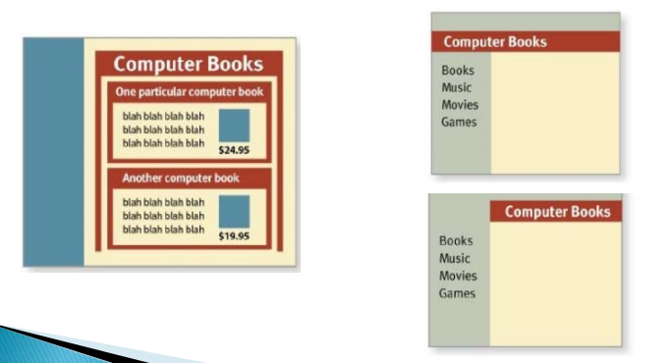

Chunking.

* A chunk is a unit of information in short-term memory.
* Chunking is a technique that seeks to place the information in a way that accommodates to the limits the humans have to process bits of information.
  + Smaller chunks are easier to remember than larger lists: Most people can remember a list of 5 words for 30 seconds, but few can remember a list of 10 words for 30 seconds.
  + Magical number: 7+/- 2 (contemporary estimation 4+/-1 ◊ 5)
* It refers to elements that must be memorize:
  + Menu items, telephone numbers…
* But it is not required to divide all the elements in a screen or page in groups of 5 or so, just the information to be memorized.
  + Elements such a dictionary pages must not be.

Color.

* It is an important feature that can make a design more visually pleasing and aesthetic.
* Can be used to reinforce layout design and the meaning of elements.

Aspects to consider:

* Number of colors:
  + Keep it low, up to five. Define a COLOR PALETTE.
  + Use a second cue.
* Color combinations (more later):
  + Analogous (neighbors), complementary, or combinations of colors found in nature.
* Saturation: Attracts attention.
  + When performance and efficiency are important, the use of desaturated colors may help, perceived as more professional.
  + Saturated colors attract attention and are perceived as more exciting and dynamic (but may increase eye fatigue).
* Symbolism:
  + The meanings of colors may vary among cultures.

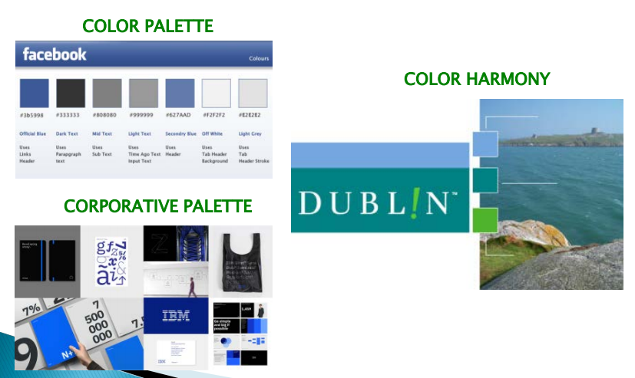

LATCH principle.

Information is organized according to:

* Location: Information comes from different places.
  + (cities in a map, medicine: location of the body).
* Alphabet: Usually for large amounts of data
  + (words in dictionary…).
* Time: Events with fixed durations.
  + (meeting schedules).
* Category: To classify goods/elements of similar importance.
  + Suitable for shops…
* Hierarchy: By magnitude, order of importance.

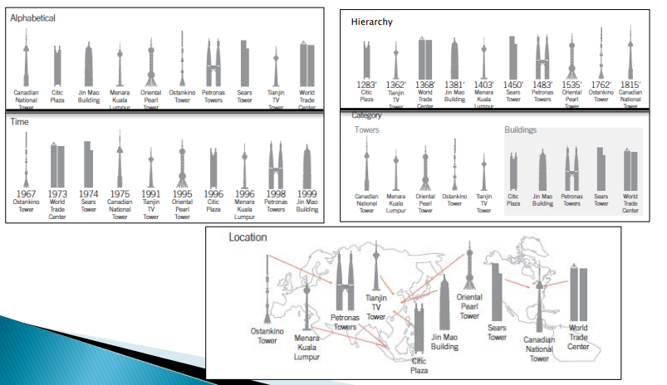

Garbage-in garbage-out (GIGO).

Computer scientists have long known that inadequate input information often generates bad results.

Type error: The input is provided in an incorrect type (mistakes).

* If undetected, it may generate large amounts of garbage.
  + Ex.: Numerical fields filled with a phone number or credit card number…
  + Type checks, input formatting, default values, example of inputs.

Quality error: The input has the correct type but has some defects (slips).

* Ex.: Amounts of money in a money transfer.
* 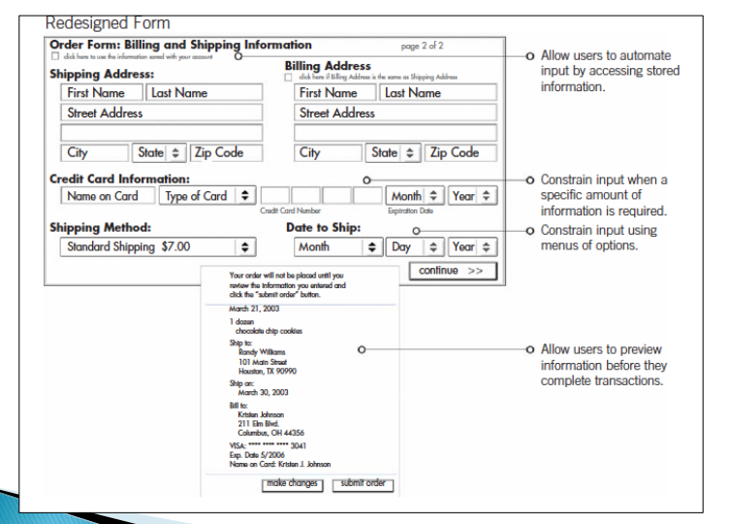May be alleviated with confirmations and previews.

Input control: avoid errors.

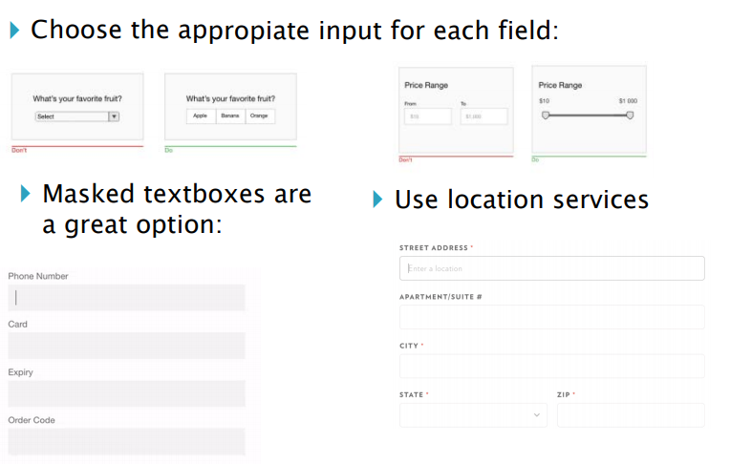

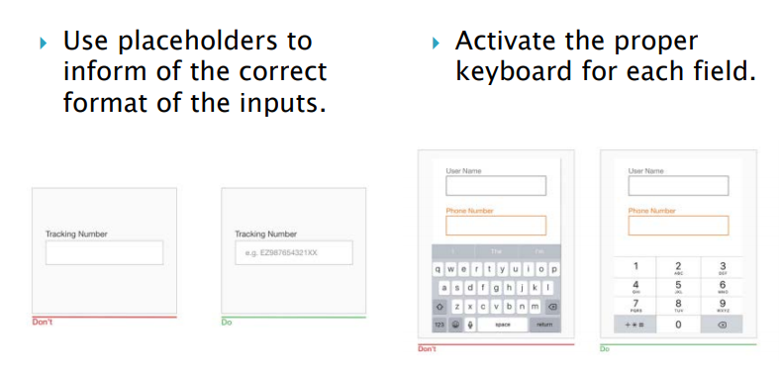

Iconic representation.

Images try to represent objects or actions.

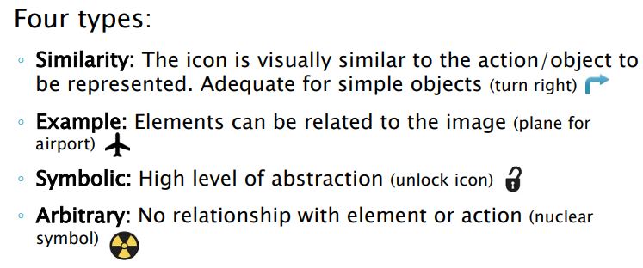

**Perception Laws in Design: Gestalt Laws & more**

**Gestalt Laws relevant for visual design.**

Gestalt: Psychology term - people tend to organize visual elements into groups when certain principles are applied.

Gestalt Laws are:

* Prägnanz Law.
* The law of closure.
* The law of similarity.
* The law of proximity.
* The law of symmetry.
* The law of continuity.
* The law of common fate.

Pragnänz Law:

Law of good figure, simplicity. We tend to perceive simpler shapes because it is the interpretation that requires the least cognitive effort to us.



The law of closure:

The mind may experience elements it does not perceive through sensation, in order to complete a regular figure.

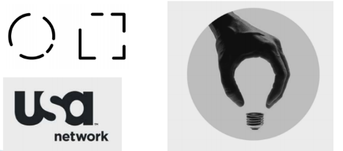

The law of similarity:

The mind groups similar elements into collective entities or totalities. This similarity might depend on relationships of form, color, size, or brightness.

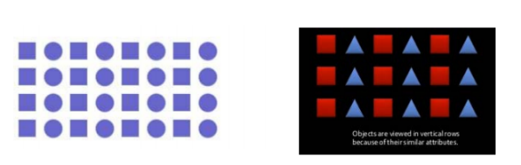

The law of proximity:

Spatial or temporal proximity of elements may induce the mind to perceive a collective or totality.

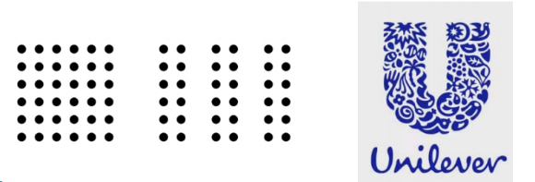

The law of symmetry:

Symmetrical images are perceived collectively, even in spite of distance.

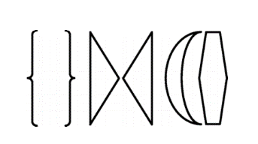

The law of continuity:

The mind continues visual, auditory, and kinetic patterns. Elements on a line/curve may be perceived as more related than elements not on the line/curve.

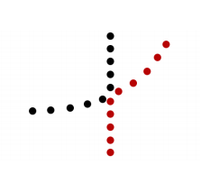

The law of common fate:

Elements with the same moving direction are perceived as a collective or unit.



Example:

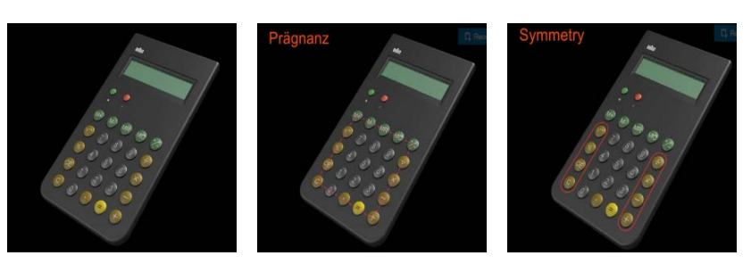

**Perception laws**

Orientation Sensitivity:

Efficient perception of line orientation is highly limited.

Vertical or horizontal orientations are ok, while oblique orientations are more difficult to distinguish (30º is de minimum recommended).

Due to two main phenomena in visual perception:

* Oblique effect: The relative deficiency in perceptual performance of our neurons for oblique contours as compared to the performance for horizontal or vertical contours.
* Pop-out effect: It is the tendency of certain elements in a display to pop out as figure elements, and therefore be easily detectable. Better if they differ minimum 30º

Pictorial superiority effect:

Concepts are much more likely to be remembered experientially if they are presented as pictures rather than as words.

* After 30 seconds.
* Before 30 seconds, the same amount of information can be recalled in text than in pictures.

Rule of thirds:

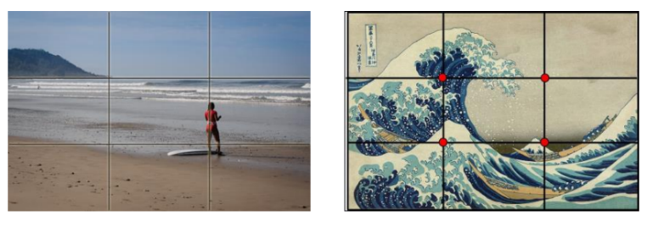

We do not read, we scan.

* People start reading from upper left corner of a page (unless the content is written in a right-to-left language).
* Navigation elements work better on the top.
* Users "read" a page diagonally, from upper left corner to lower right one, or in Z or F scan.
* Users pay attention to menu and navigation buttons.
* They commit to headlines.
* They ignore huge blocks of text while scanning.
* Lists hold attention for a longer time.
* Short paragraphs are easier to perceive.
* Users pay attention to subheadings only if they are interesting.

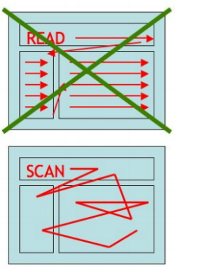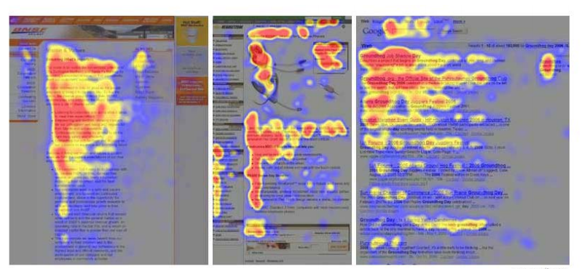

Signal to noise ratio:

Measure used in science and engineering that compares the level of a desired signal to the level of background noise.

* A ratio higher than 1:1 indicates more signal than noise.
* The goal of communication is maximizing signal and minimizing noise.

Keep de design simple => enhance perception We can enhance information by using redundant coding and highlighting. Remove noise by eliminating unnecessary elements.

**Design with color**

Human vision:

Photoreceptors:

* Rods:
  + Only one kind (peak response in green wavelengths)
  + Sensitives to low light, saturate at moderate light.
* Cones:
  + Operate in brighter light.
  + Three kinds: S (are weak, centered in Blue), M &L (more powerful, overlapping frequencies, M centered in Green, L in Red).

Signals from Photoreceptors:

* Brightness (M + L + rods)
* Red-Green difference (L-M).
* Blue-yellow (S- (L+M)).

Contrasting colors:

* Opponent colors: R/G, B/W, B/Y.

Color perception problems:

Color blindness:

* Inability to distinguish the colors the same way than noncolor impaired people.
  + 5-10% of men.
  + 1-2% of women.

Most common types of color blindness are:

* Deuteranopia (M cones): Reduced sensitivity to green light (common).
* Protanopia (L cones): Reduced sensitivity to red light (rare).
* Tritanopia (S cones): Reduced sensitivity to blue light (very rare).
* Achromatopsia: Cannot see any color at all. Also, not very common.

Color blindness simulation (affects the three channels):

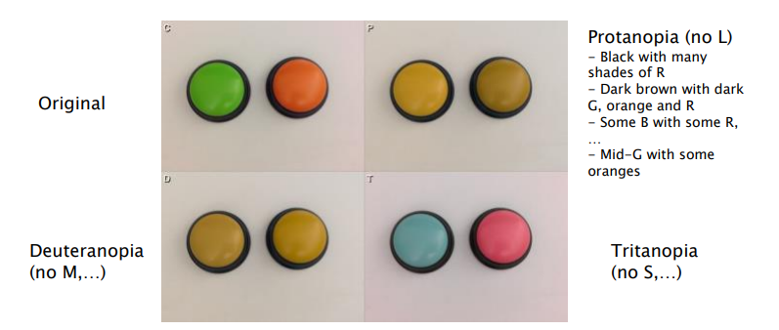

Relatively easy to detect with Ishihara tests:

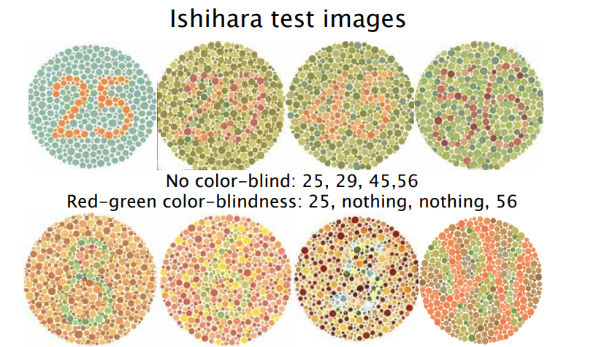

Other vision problems:

* About 4% of the population have low vision (0.6% are blind).
* Low-vision conditions increase with age.
  + Half of people over 50 have some degree of low-vision condition-
* Worldwide, the fastest-growing population is 60+ years.
  + Over 40, almost everyone needs corrected vision to clearly see small objects or text.
  + Age-related vision problems include macular degeneration, diabetic retinopathy, cataracts, and retinitis pigmentosa.
* Size and spatial frequency are also important in perception.
  + The higher the spatial frequency the lower the saturation (e.g., chessboard).
* Chromatic adaptation: Illumination changes affect the colors dramatically.
  + Human perception adapts to changes.
  + Does not perceive those changes linearly.

Light color models:

All the channels sum up to white light.

RGB: Red, Green and Blue.

The HSV color model:

* H: Hue or chroma.
* S: Saturation (intensity of color).
* V: Value (black to color).

Pigment based color models:

All the channels sum up to black color.

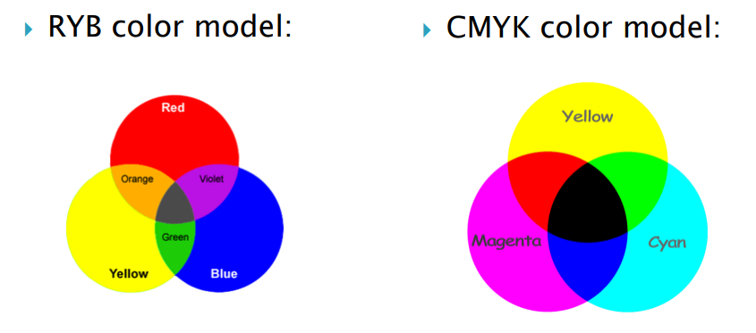

Tips for color selection:

Color friendly design (most concepts based on HSV model):

* Few colors. Similar colors should infer a similarity among objects.
  + i.e., red for error, green for success, yellow for alert, blue information.
* Avoid using adjacent strongly saturated colors.
* Contrast dark colors against light colors.
* Content areas should be monochromatic with the font color and background at the opposite ends of the color saturation poles.
* Elements of navigation, headers and sub-headers, require some extra visual enhancement.

**Color design rules:**

* Use color only when needed to serve a particular communication goal.
* Use small number of colors (hues).
* Avoid strongly saturated colors.

If you want objects to be easily seen, use a background color that contrasts sufficiently with the object. For text is usually needed a combination of contrast of Hue+ V & S Contrast “dark” (high S, Low V) with “light” colors (Low S, high V).

If you want different objects of the same color to look the same, make sure that the background (the color that surrounds them) is consistent.

Use different colors only when they correspond to differences of meaning in the data.

* Highlight particular data, group items, encode quantitative values…

Use soft, natural colors to display most information and bright and/or dark colors to highlight information that requires greater attention.

**Color design rules (palettes):**

When using color to encode a sequential range of quantitative values:

* Use a single hue (or a small set of closely related hues) and vary intensity …
  + …from pale colors for low values …
  + ...to increasingly darker and brighter colors for high values.

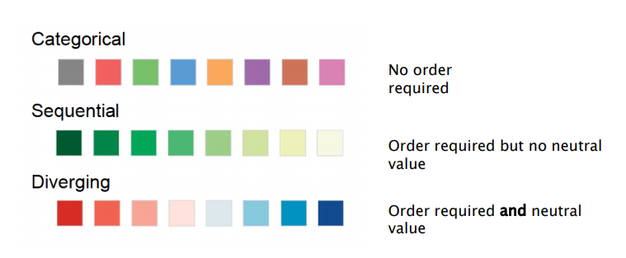

**Color design rules (in charts/tables):**

Non-data components of tables and graphs should be displayed just visibly enough to perform their role, but no more so, for excessive salience could cause them to distract attention from the data.

**Color design rules:**

* De-emphasizing…

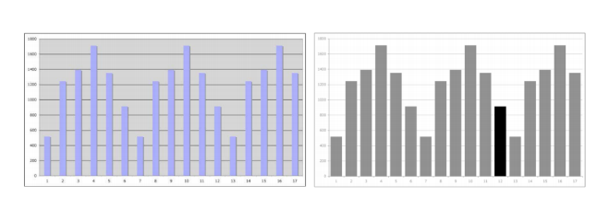

* Avoid using a combination of red and green in the same display.
* Use opposite colors.
* Color Wheels.

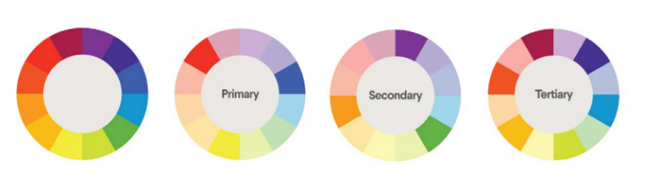

* Analogous colors.

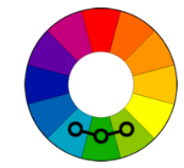

* Complementary colors.

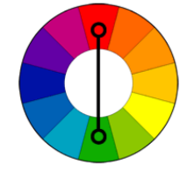

* Split-complementary colors.

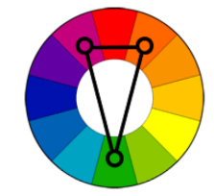

* Triad relationship.

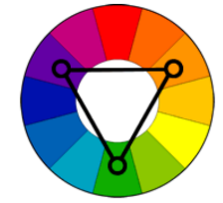

* Tetrad relationship.

